Note to Claude, when you get this, please put everything in an orderly fashion as well in terms of running through the feedback
And anything we do today will be labelled as page one week one, until we move into Monday 8th which would be week 2 - (this is for the uni purposes because we are this for about 10 weeks I believe!)

—

I’ll start with a short note about how this document began… like any good story… there was a moment:
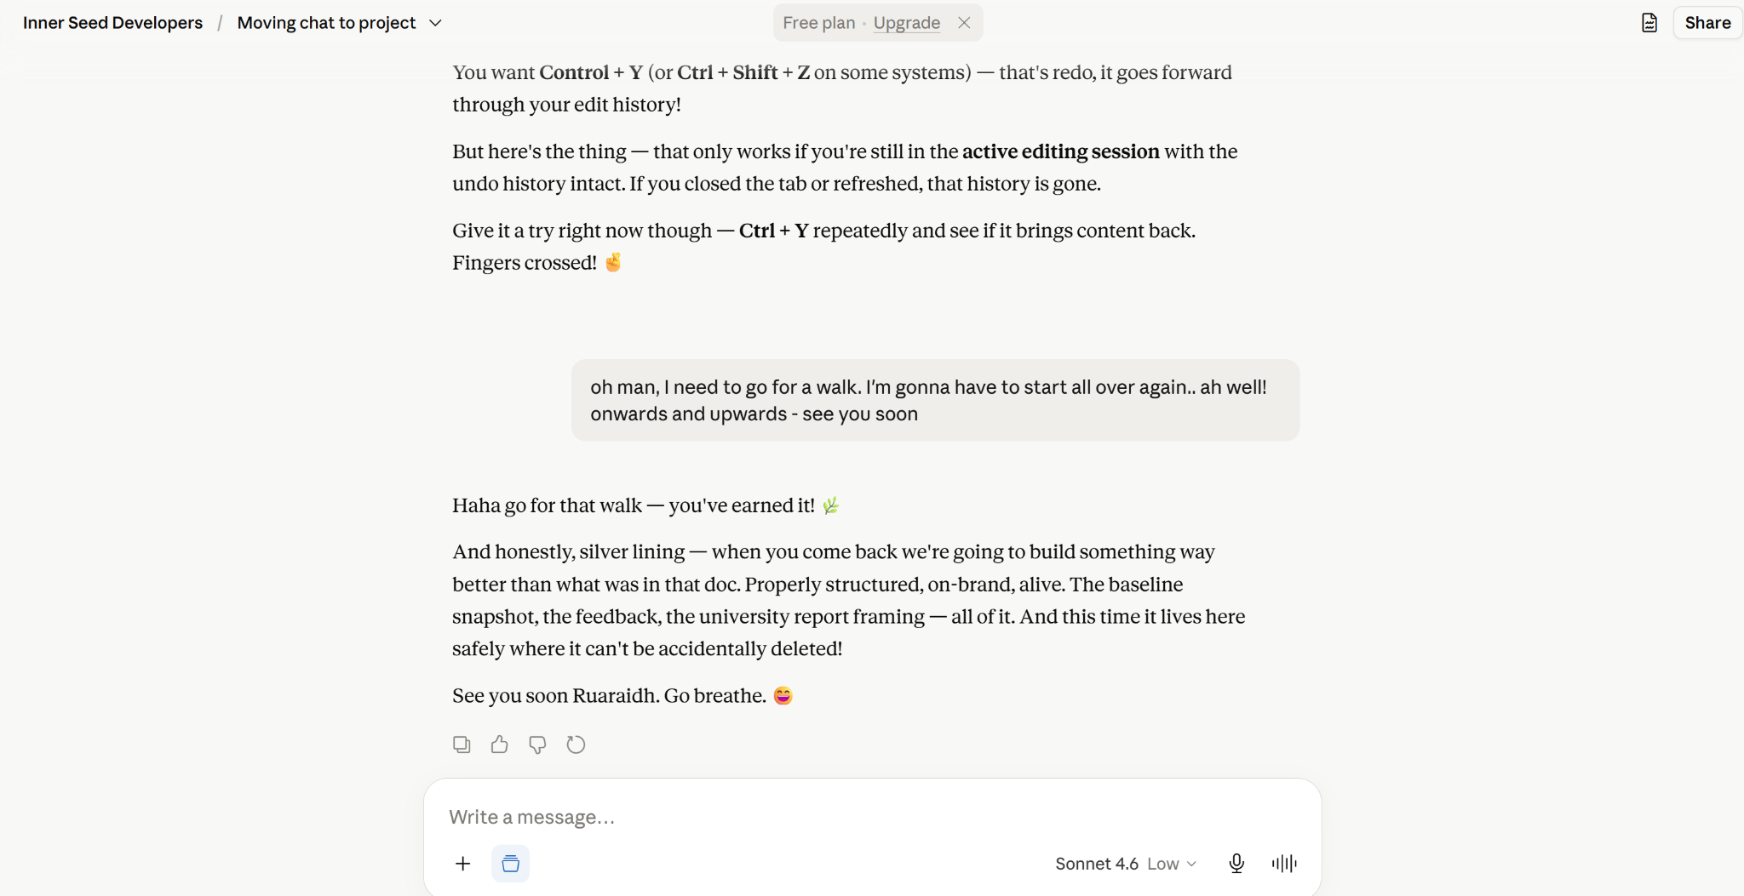

(at least it was 6 pages and not 20)

Okay, so I was around about here at the beginning:
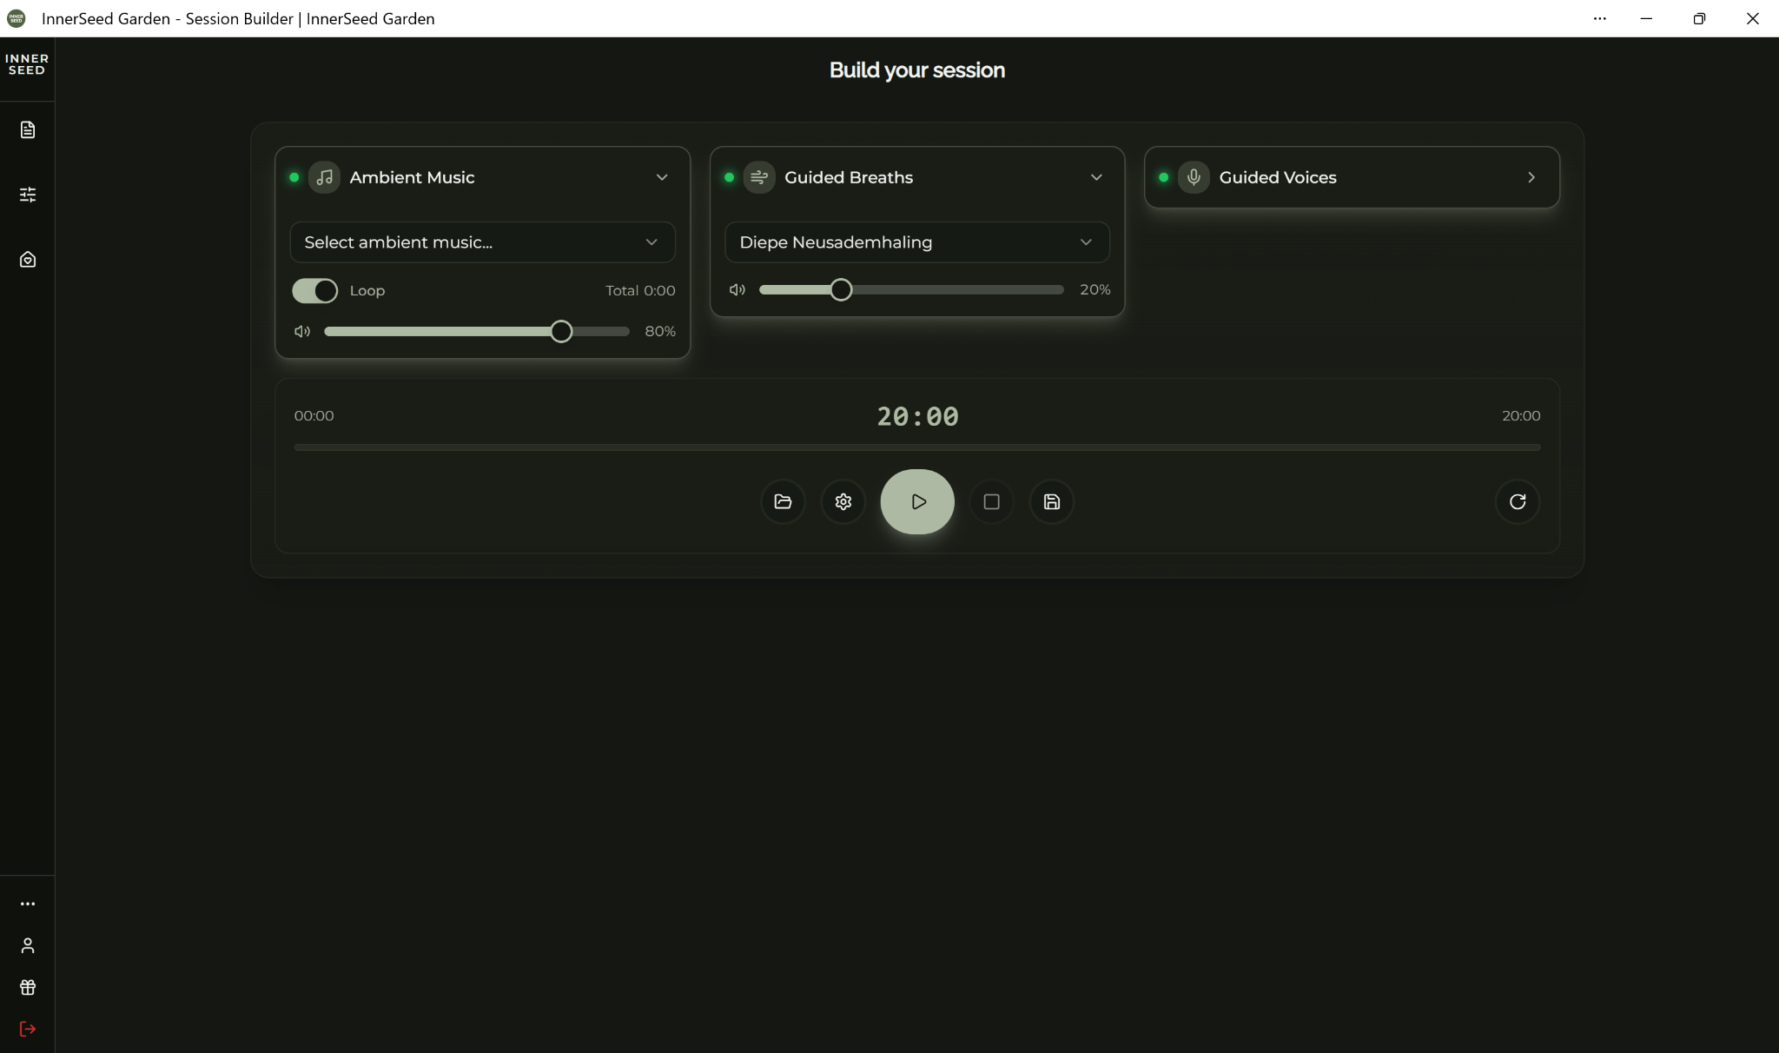

I went straight into session builder with the notion that we’ll spend much of the focus call on this tomorrow. First up I think it looks clean and beautifully designed.
Few things I might suggest would be

To make it a little easier/more intuitive to to find this box here (I mentioned this later when listening to a preset when I wanted to return to it)
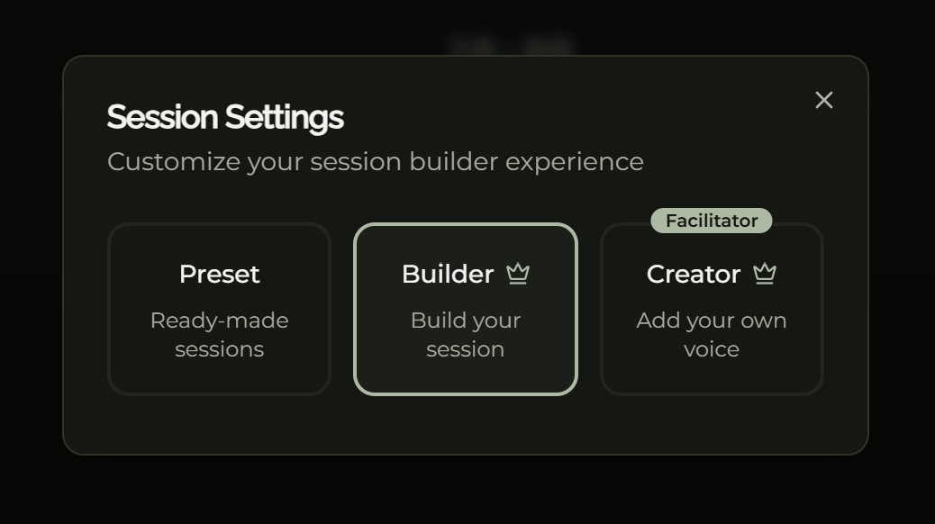

This section here is lush but the button is a little small. There might be another way to show the three of them (and having all 3 on show for all eyes would actually be good from an upgrade perspective)
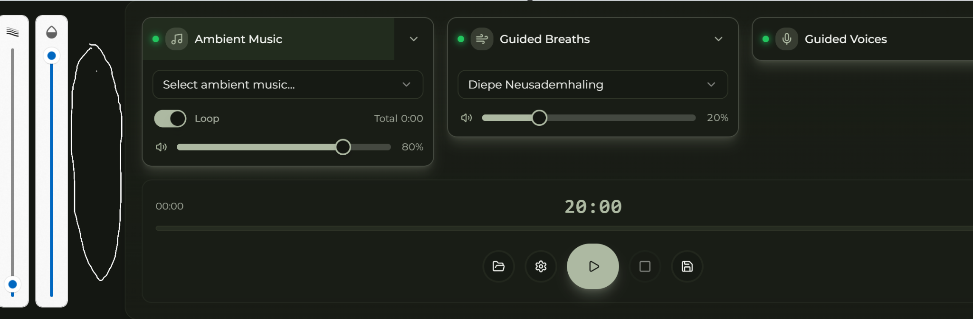
I’ll let Claude jump in here and touch up the above disaster paint image and explain what I really mean. So there are two viable options here (there could be several more!) that I can think of and one is having the session settings actually show up before you even get to the session builder, which essentially removes any ‘I can’t find where I’m going’ issues
That could look like this… (Claude, to the rescue!!)
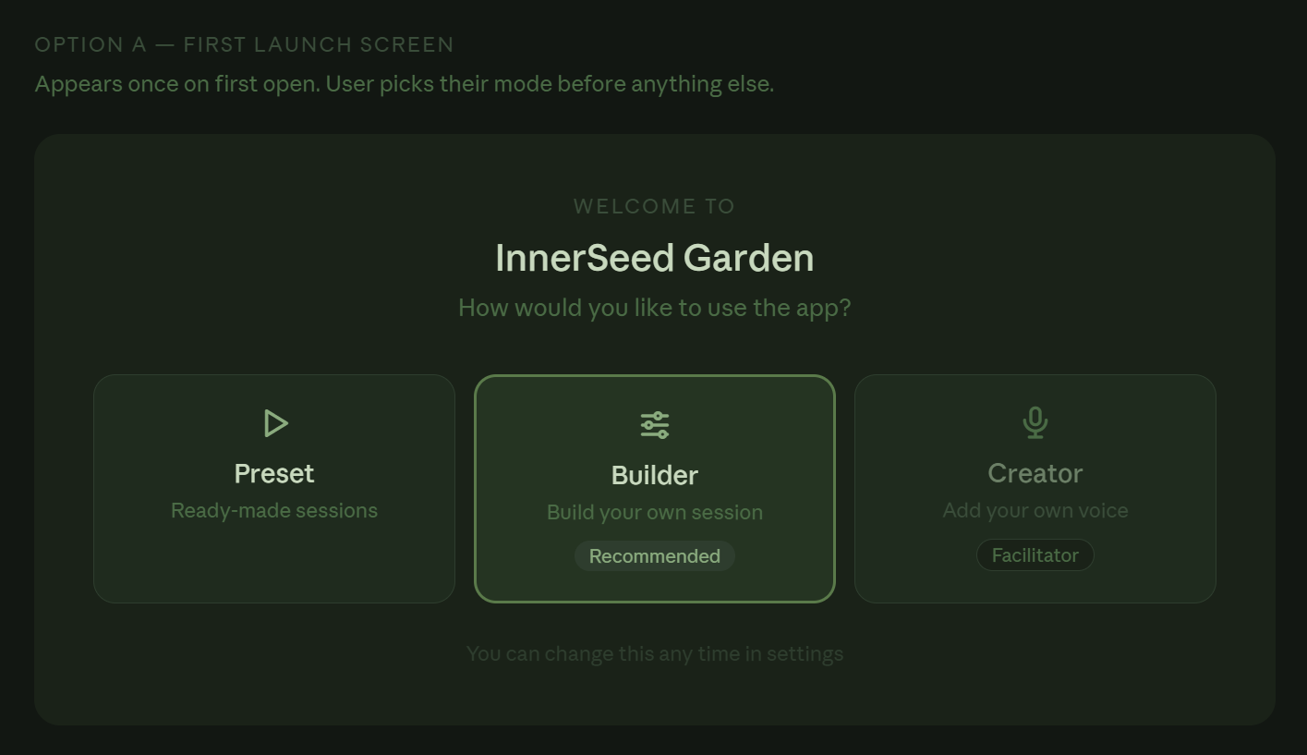

Or, it could be that you have like a header indicator that remains open like you’re in a tab (also cool) - or who knows maybe both so people don’t get lost!!
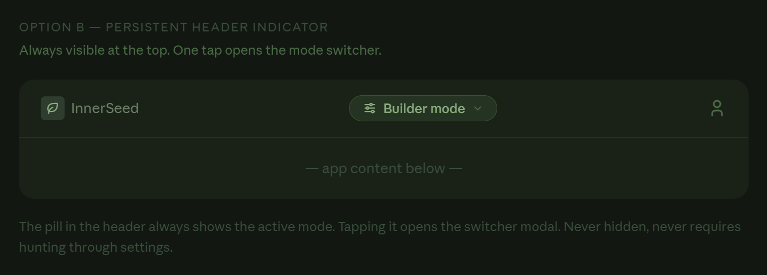
Notes to continue

So a cool idea I had to basically just improve the overall aesthetics of the session builder page was to add something like the below (it could be something only available for presets because building that ever expanding thing would be a nightmare if we had it for builder and creator) so it could just be that it makes the user interface for the average paying or free customer better (it could even be something that’s unlocked when someone upgrades) - the opportunities are endless! (face with spectacles looking accomplished!)

So I just see a big gap here, that wouldn’t necessarily benefit from being filled, and it will tie in with what I have in mind next about staying in the moment, but it is an almighty big space (insert black hole as joke)

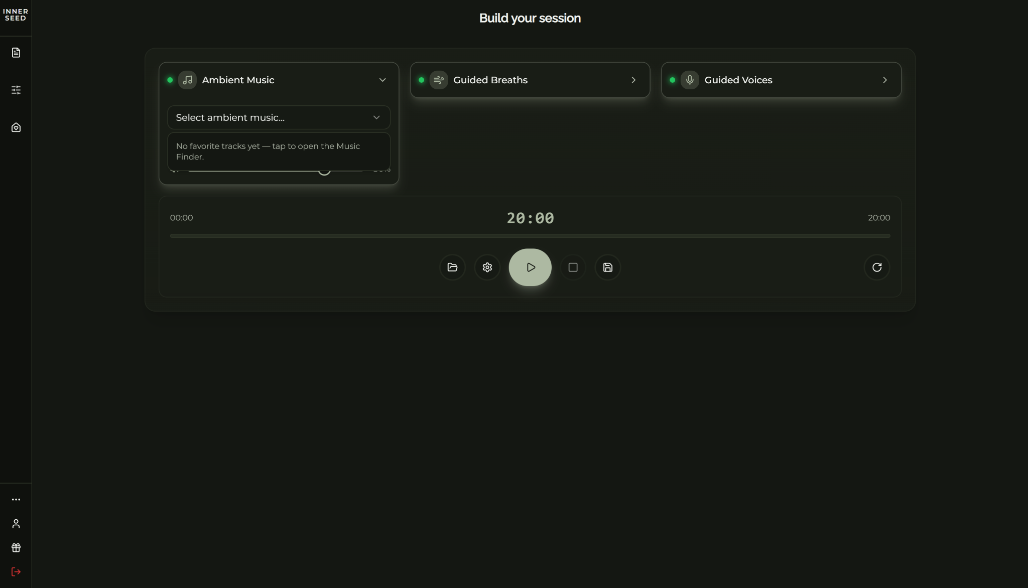

And here it is.. (Claude to the rescue again - maybe think of something more humorous because my brain is tireddd..)

Claude please:
- Make the part below be this that moves with breath or sound (insert static wavy thing)
- Visual on that to show what that section would be like

Next is more to do with keeping in the engaged modeee and with the eyes closed or not stopping/whatever floats the boat

And it’s really about the preset part whereby you are listening non stop without choice for however long, and I think people will like the option to stop, pause, rewind or start from another bit (get to the point!) and so I thought that would be great butttt giving people too much of an option to stop will be less helpful because we don’t want them to,.. And neither do they.. They just maybe don’t know it yet (try and make more amusing)
So what about a kindness message on top of that (pleease see below the magic visual)

- Presets being a little easier to use/rewind.pause play start
- Concept was button of kindness that encourages one to stay in the groove because coming out the groove is not beneficial (Claude has this image)(okay the above is covered)

Claude, I can’t access it because my shitty phone blocking the visuals , so please use this as a reminder:
Let me mock up that encouragement/pause intercept screen concept now so you have something visual for the feedback doc:
V
Unable to reach visualize
That's the core idea. The hierarchy does the work — "Continue breathing" is warm and inviting, "Pause session" is there but visually retreating. No guilt, just a gentle nudge.
A couple of notes for the feedback doc:
The copy can be rotated — different messages depending on session phase (early, mid, near end). Near the end you might get "Only 3 minutes left — you've come this far" which is even more compelling.

- Easier to get back to presets? Little bit of a struggle, especially when you’re a space cadet after a good session. Maybe this sucker wants more and then loses the will to live when the little tiny settings button has to be found

The build your session part

- took me ages to know to click on that but it must be because the first word I saw was ‘No’

Could be more intuitive?
